Web Application Development Log

Design Section

Project link on Github:
https://github.com/I-F0RG0T/Searching-for-a-repo-that-doesn-t-exist.git

Project name:
Game website

Project Summary: Include purpose and target audience
In this project or website Im making is about having pages of different type of games from different genres to help people find and show games they they might like. The website is for gamers and like to talk about their favourite game to people who like the similar game as say user.

As someone who love games and like learning new games, i feel like this website will be help for people who want to start playing games or looking for new games to play.

Initial Database Design ERD:
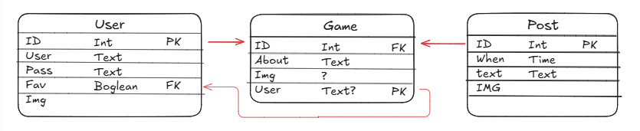

WebPage Design- Wireframe and/or Palette
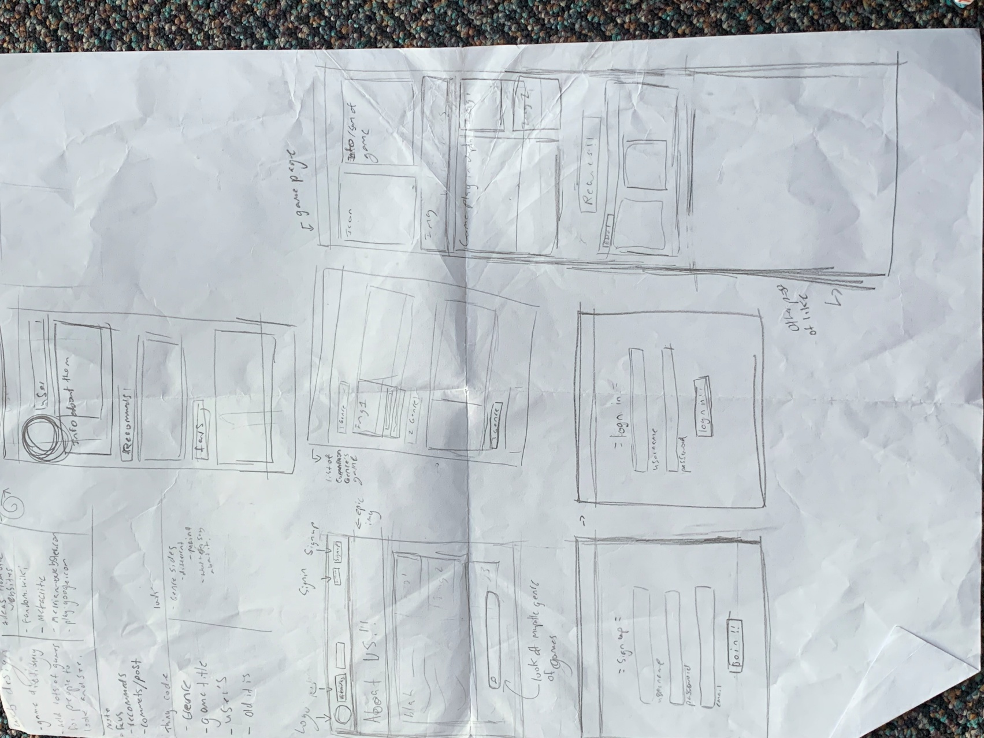

Relevant Implications (explain at least 3)- Before Development.
Intellectual Property –
My website is fosours on Games, which could break copyright. Since I want to use imgseas and maube viedos from the games, it could be be condiser copyright as the imahes and vides are not own my me but someone else. I can propalby get around this by asking game creoters or people who own these videos and images if I can use those in my website, and depending on what they sau. I can use what media I want from them, without fearing for copyright.

Ethics –
Games have many grerons and looks with them. One of the big cornales are FPS or those whoa re rated 16+. I want user for all ages who love games and I cant limited who loves playing games just because centeesons games are not rated PG. To get around this would be putting a warning before entering a game page or a way to tell user “hey! This page contions gorey or dispurting imgs!”, without feeling uncomable or tramuaizes when on the page. Or, make it that centes pages can show in centes age rang, but that would be too hard for me to do :,)
This allow people to roam around the webite without feeling they going to be jumpsared by 16+ sfuff when opening a page.

Accessiablity-
Anyone can be a cool gamer. Having people who have disabliltyt unable to access this website is very bad cause people with siapablity can be gamers. Ill change this
I want to have opeiton of font, colours pattion, and other things for people to change and use for their conmfortr. They can e able to change fonts size and looks to give an expmael. That all I got.

Sprint #1

Sprint #1 Goals
(before starting sprint 1):
My goals for this sprint is to make an about page, login and sign up, and Navigation Bar.

Sprint #1 Testing
Include tests for everything in your application including all links, input forms, correctness of data and correctness of queries. Add more columns as required.
Testing Table
What are you testing | How are you testing it | Expected Result | Pass/Fail
Going on to another page on the site | Press button and go to site |  | Fail
Going on the other page part 2 | Same thing LOL |  | Pass
Navigaiton Bar | I check if the css of the nagvigation bar. | 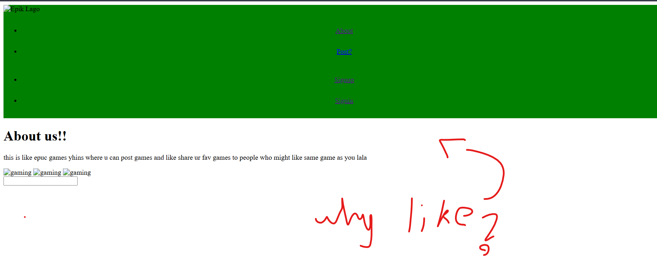 | Fail
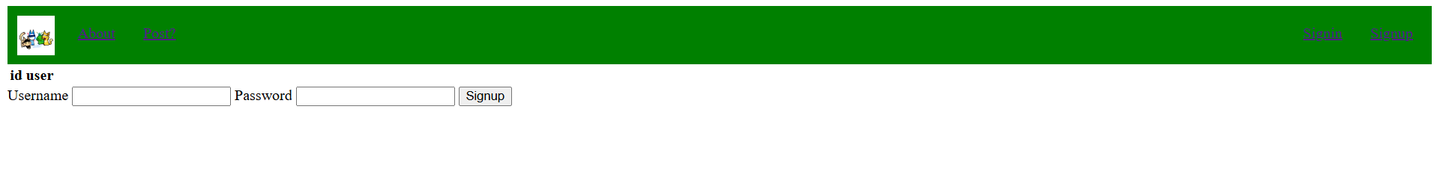  Navigaiton Bar | I check if the css of the nagvigation bar. |  | Pass

Sprint #1 Review
Progress Review (100+ words)
MY LAPTOP SUCKS AND I COULDN’T DO ANYTHING!!
The only thing I did was the Navigation bar and having another page up. Nothing else for other things.

I was unable to work on my website because the laptop I was use made it unusable to get work on in this class (and others too), and it being a hassle to trying to figure it out how to use it. I only got the navigation bar to work, but it kind of sucks and looks bad. I was also unable to write and document my work (or lack on it) on here because it was slow and I had nothing to show

Sprint #2

Sprint #2 Goals
(before starting sprint):
- At least have have something different than before.
- functionally Navigation Bar
- Text box input thing for users to type in for stuff.

Database improvements (if any)
Entity Relationship Diagram

WebPage Design Improvements (if any)- Wireframe/Sketches/Pallette/Font etc
- I add colour for fillaur. Is ugle
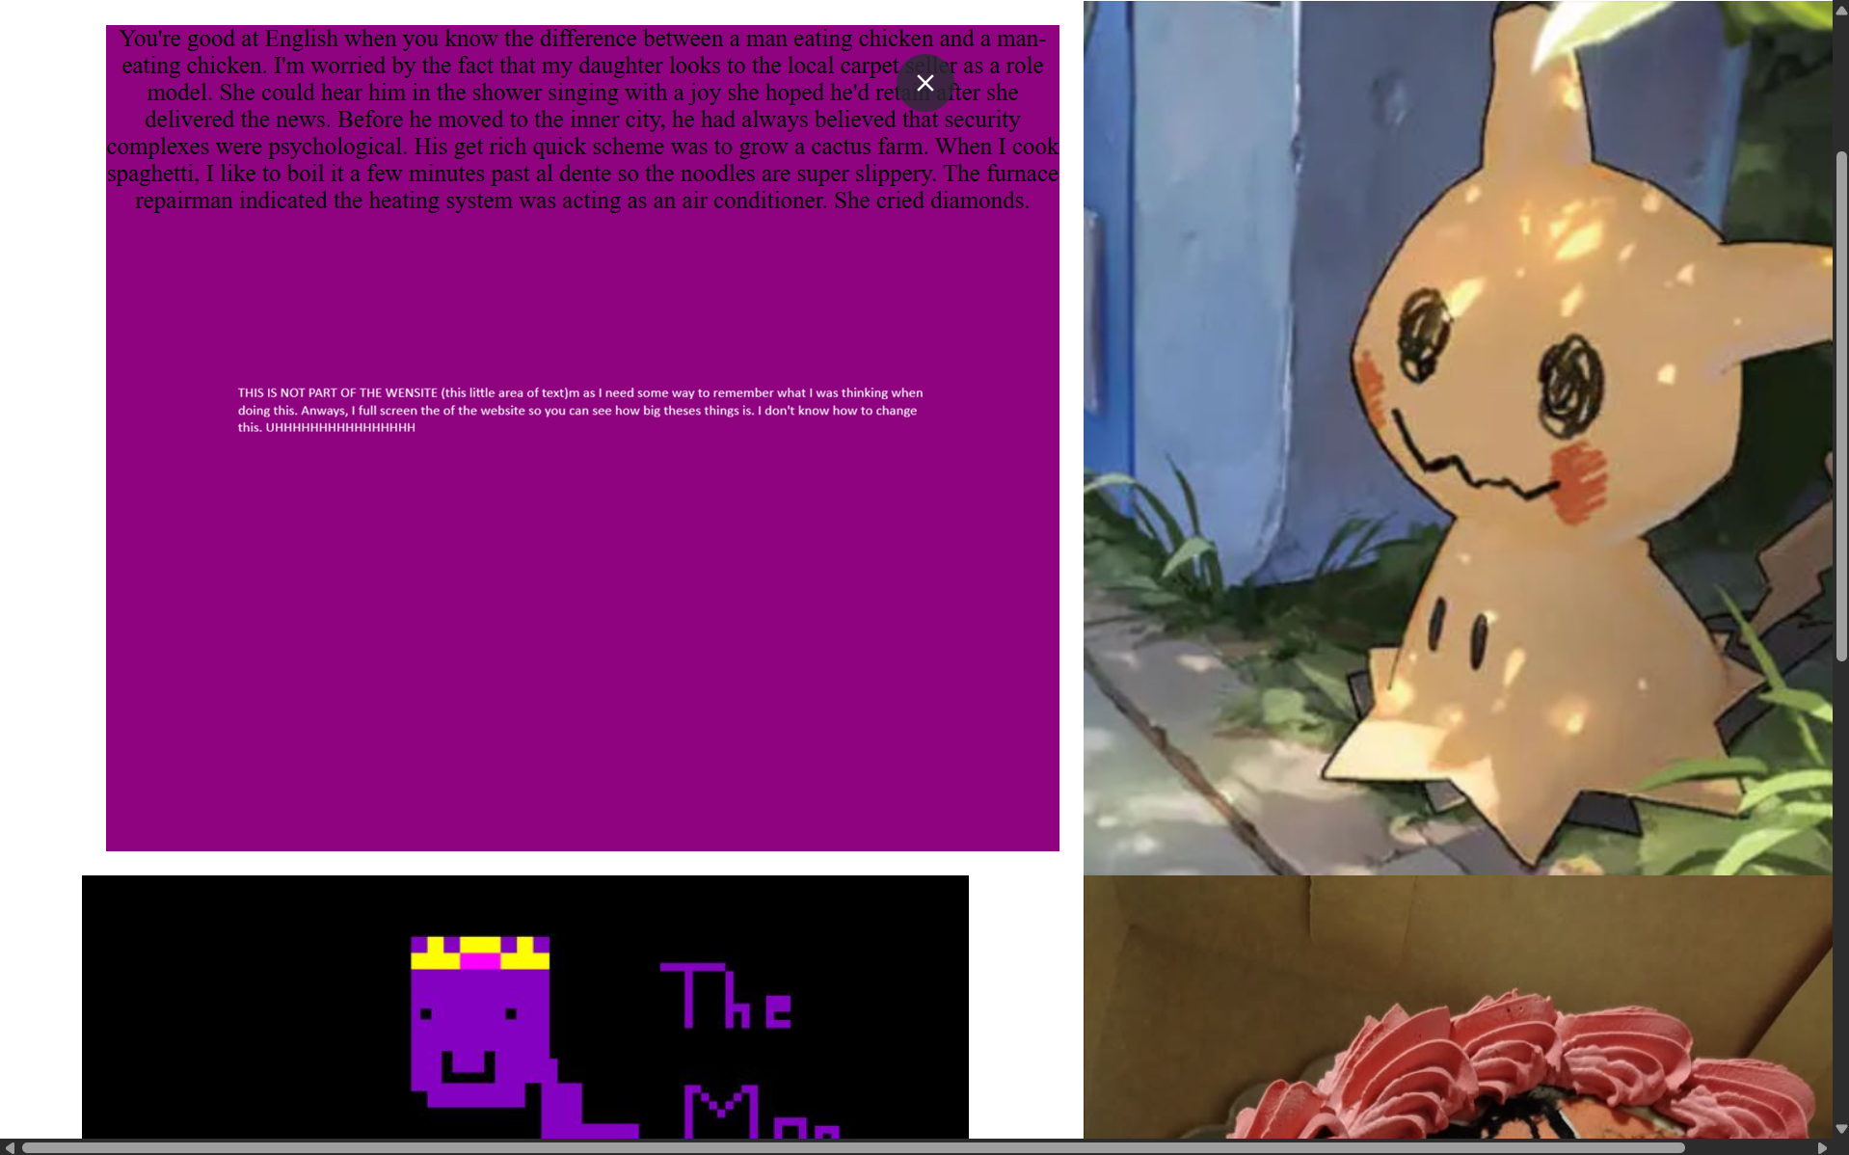

Sprint #2 Testing
Include tests for everything in your application including all links, input forms, correctness of data and correctness of queries. Add more columns as required.
Testing Table
What are you testing | How are you testing it | Expected Result | Pass/Fail
Text box | grid area | I check if the grid box is working the way I want it to be. | 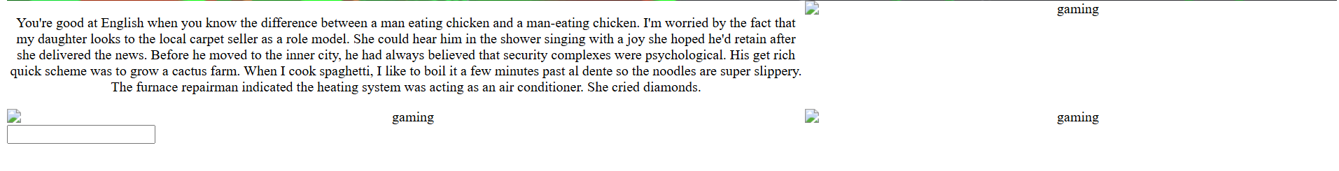 | Fail
Text box | grid area | I check if the grid box is working the way I want it to be. |  | Fail
Text box | grid area | I check if the grid box is working the way I want it to be. | 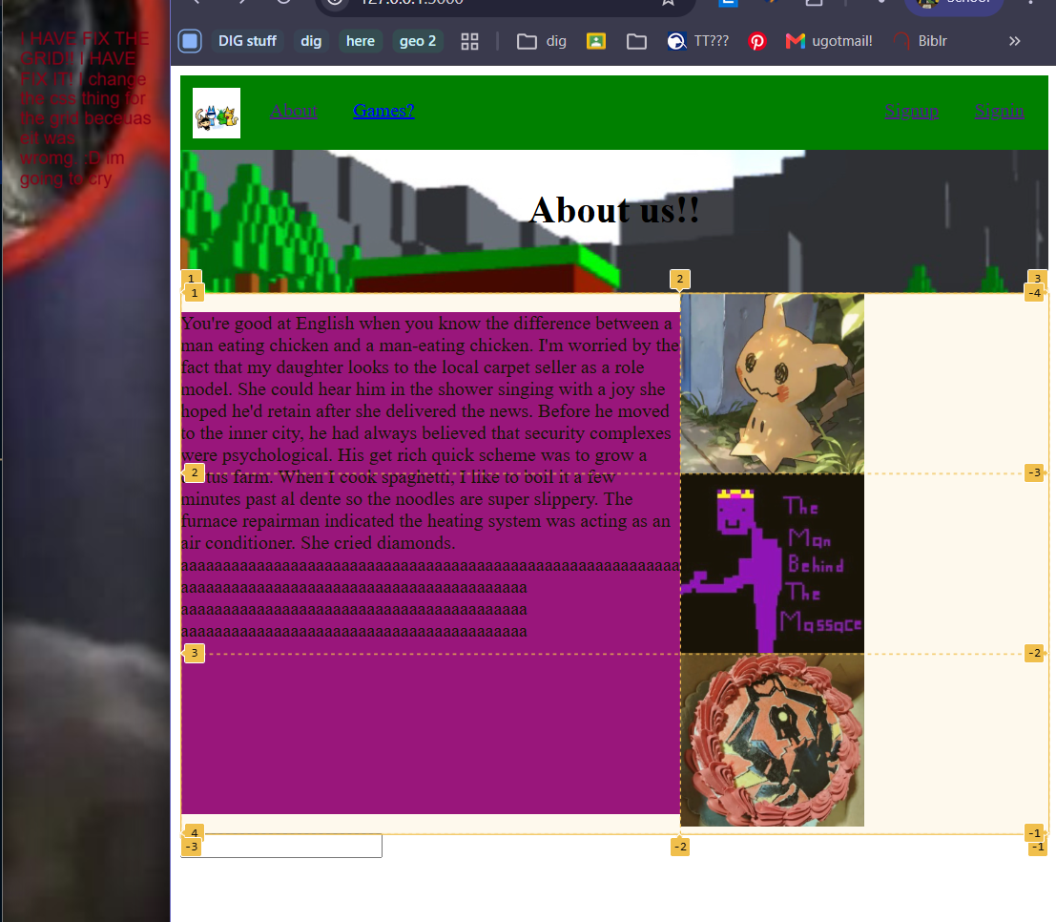 | pass
buttom | Enter thing. But send you tp anpther page |  | no
Sign up text box

Sprint #2 Review
Progress Review (100+ words)
I got another laptop. Is better and I love it.

I fix up the main page (the about the website) and how it look.

I should probably do more things on here because I am very far behind on what I support to be working on. I do hoping that I can fiinihs the sign up and logn in page, aswell as fixing the main page.

Sprint #3

Sprint #3 Goals
(before starting sprint):
Goals for this sprint arr to start doing dymaitona rotiinh, sign up and in pages are working and can add to the data base, and to make the website more pleascabel to look at.

Database improvements (if any)
Entity Relationship Diagram

WebPage Design Improvements (if any)- Wireframe/Sketches/Pallette/Font etc

Sprint #3 Testing
Include tests for everything in your application including all links, input forms, correctness of data and correctness of queries. Add more columns as required.
Testing Table
What are you testing | How are you testing it | Expected Result | Pass/Fail
Sign up - | Doing the form for sign up
Sign up - form | Doing the form for sign up | 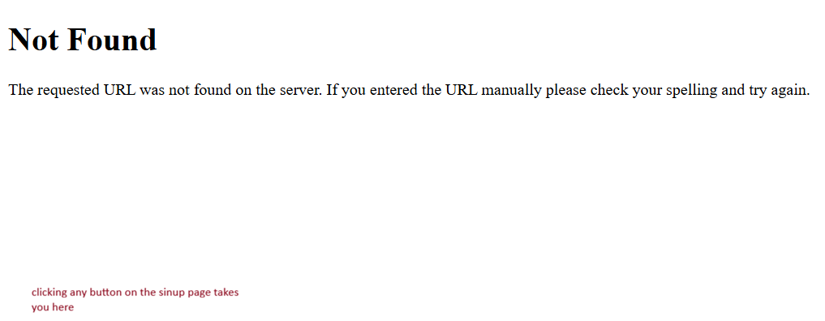 | Fail
Sign up | Doing the form for sign up | 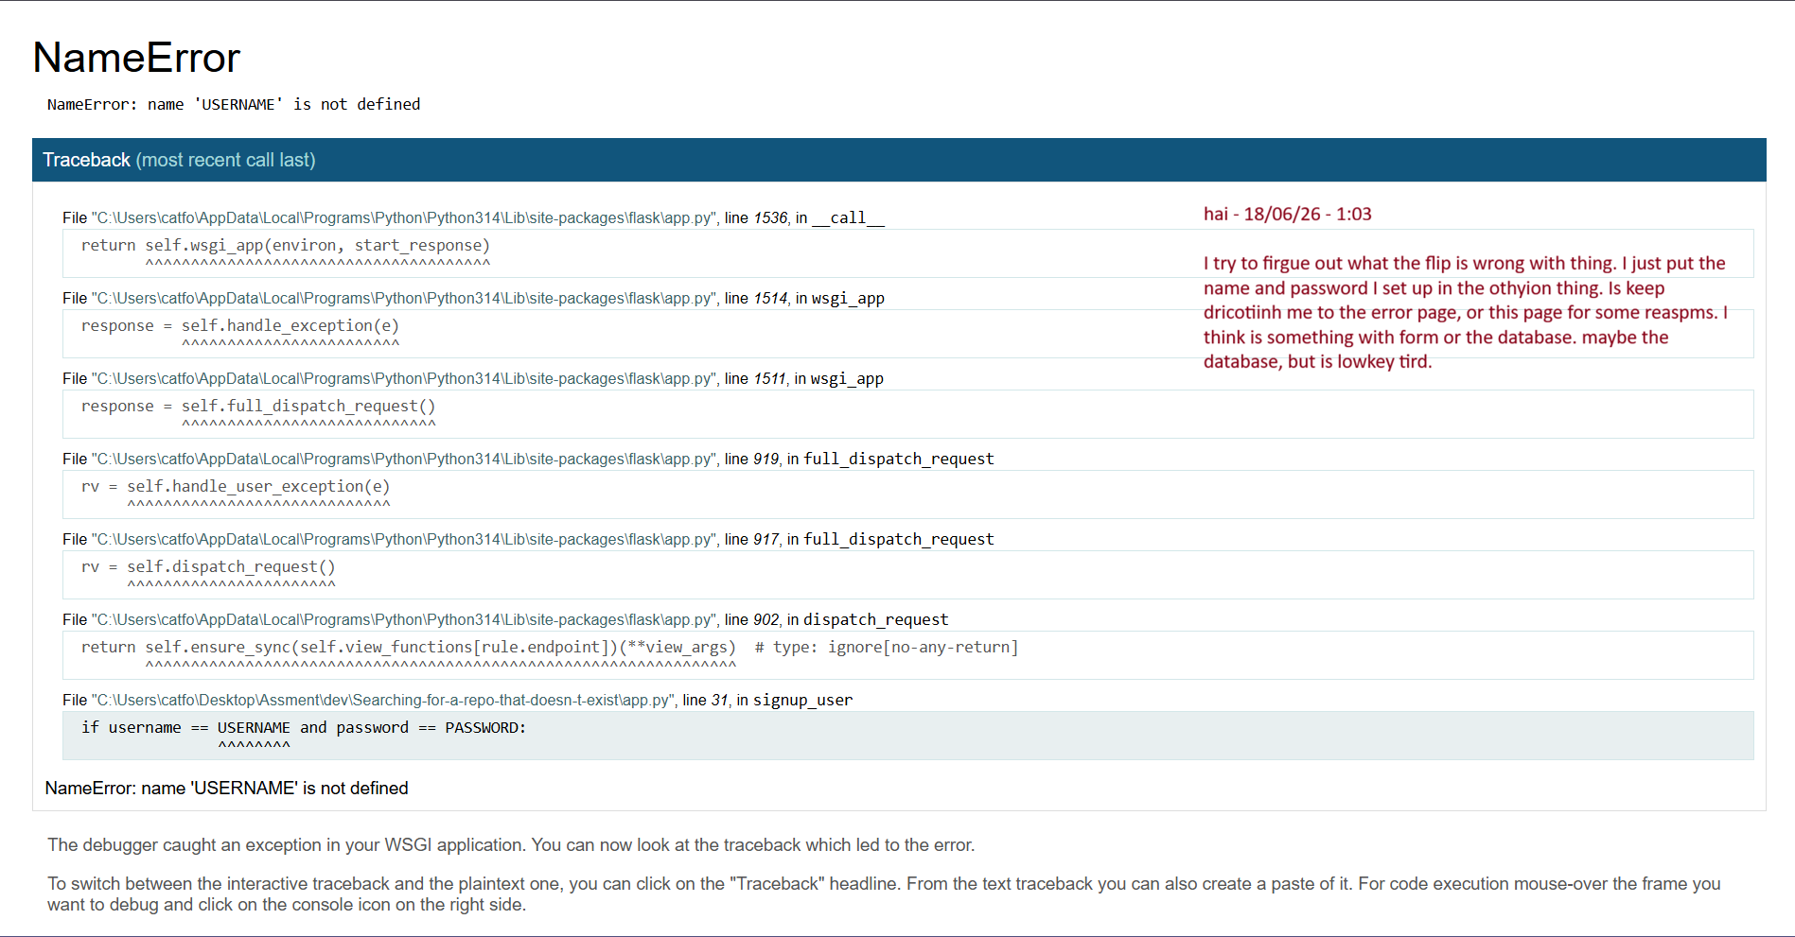 | Fail
Sign up | Doing the form for sign up |  | fail
Sign up - Form | I put the usernmae ting in the box and enter it and see if that goes to the other page I set up. |   Page thing. Yes. I change the code | Pass

Final Review
What were the results of your testing? Did you get through all that you expected to? What is causing problems? What went well? What was a challenge? What would you do differently if you had a chance?

Discuss how planning, testing and trialling led to the development of a high-quality digital technologies outcome.

How I addressed the Relevant Implications
As discussed before the project, what relevant implications had you identified at the beginning and how did you manage to address them as you went. Were there any others that you came across while making this game? How did you manage to address them? 100+ Words

Marking Schedules: For Teacher use only

AS91902- Use complex techniques to develop a database

Credits: 4 (internal)
NZQA: https://www.nzqa.govt.nz/nqfdocs/ncea-resource/achievements/2019/as91902.pdf

Achieved- develop a database | Evidence | ✔
designing the structure of the data | Made an ERD with at least ONE MANY-TO-MANY relationship before the end of the project.
using appropriate tools and advanced techniques to organise, query and present data for a purpose and end users | Competently normalized data structure  Multiple queries across linked tables  Basic Python CRUD functionality with text input/output
applying appropriate data integrity and testing procedures | Testing Logs. Do the queries work and return what is expected?
addressing relevant implications. | the application meets key relevant implications like copyright, IP (correctly sourced and attributed imagery), Privacy (eg passwords hashed) etc. May have highlighted this in final Relevant Implications Task
Merit- Develop and informed database
using information from testing procedures to improve the quality of the outcome | Suggested improvements implemented- improve database design, add or refine entities or tables and relationships  Made improved ERD(s)
structuring, organising and querying the data logically | No problems with structure and datatypes in the table. No wildcard queries, JOIN’s used efficiently.  2NF at least.
Excellence- develop a refined database
iterative improvement throughout the design, development and testing process | Improved functionality of database and refinements to structure of the data.
using efficient tools and techniques in the outcome’s production | Effectively used Version Control, extensions or tools (like sqlitestudio) and VSCode.
presenting the data effectively for the purpose and end users. | Very refined outcome providing all needed functionality

AS91903 - Use complex techniques to develop a digital media outcome
Credits: 4 (Internal)
NZQA: https://www.nzqa.govt.nz/nqfdocs/ncea-resource/achievements/2019/as91903.pdf

Achieved | Evidence
applying appropriate tools and techniques to meet the purpose and end users requirements | Coded a website in HTML and CSS. Looks and functions mostly like intended in the design.
applying appropriate data integrity and testing procedures | It functions as intended and the right pages show with the correct data when the links are clicked
Applying user experience principles relevant to the purpose of the outcome | Site has good usability (HCI)
addressing relevant implications. | the application meets key relevant implications like copyright, IP (correctly sourced and attributed imagery), Privacy (eg passwords hashed) etc. May have highlighted this in final Relevant Implications Task
Merit
using information from testing procedures to improve the quality of the outcome | Testing and sprint reviews show evidence of specific improvement made based on the testing. No lorem ipsum anymore!! Accurate Data
applying user experience principles to improve the quality of the digital media outcome. | Good HCI. Eg. generally shows “consistency and standards”, and/or “help and documentation” by having an about page. No “annoyances”
Excellence
iterative improvement throughout the design, development and testing process to produce a high-quality outcome | Must be high quality. No obvious errors or inaccurate data.
using efficient tools and techniques in the outcome’s production. | Kept a good log, used github to keep backups and record of work, lots of commits on github.

AS91906 - Use complex programming techniques to develop a computer program

Credits: 6 (Internal)
NZQA: https://www.nzqa.govt.nz/nqfdocs/ncea-resource/achievements/2019/as91906.pdf

Achieved | Evidence
writing code for a program that performs a specified task | Applications works as intended.
using complex techniques in a suitable programming language | “programming or writing code for a graphical user interface (GUI)” flask requires that  “reading from, or writing to, files or other persistent storage ”- the sqlite file  “using additional non-core libraries”- using Flask.
setting out the program code clearly and documenting the program with comments | Some code comments, code layed out relatively cleanly with constants/variable at the top, routes and functions after.
testing and debugging the program to ensure that it works on a sample of expected cases. | Testing table shows the basic web page functionality was tested.
Merit
documenting the program with appropriate names and organised comments that describe code function and behaviour | Good variable and function names. Good and plentiful code comments.
following conventions for the chosen programming language | PEP8 Followed. Use Pylint or similar and check linting.
testing and debugging the program effectively to ensure that it works on a sample of both expected cases and relevant boundary cases. | Lots of testing including request for non-existent id returning an error 404 page.
Excellence
ensuring that the program is a well-structured, logical response to the specified task | Enhanced program, e.g. functions that aren’t routes to make the code cleaner (eg query_db). Neat and logical code.
making the program flexible and robust | Great structure making code easy to extend. Unbreakable code. Eg. Error-404 and error 505 handlers
comprehensively testing and debugging the program. | Unbreakable code with a lot of tests done for every testable element of the program including unexpected input like a non existent route or page returning custom error 404 handler

